Civil war in Liberia

UNSC Resolution: | 1509
Date of adoption: | 19-Sep-2003
Operative paragraph: | 8
Demand number: | 1509,0811

Sarah-Myriam Martin-Brûlé

Wording of demand

ensure, in accordance with relevant provisions of international law, the full, safe and unhindered access of relief personnel to all those in need and delivery of humanitarian assistance, in particular to internally displaced persons and refugees

List of addressees of the demand

Government of Liberia, Movement for Democracy in Liberia, Liberians United for Reconciliation and Democracy

Short-term compliance

Description of the addressee(s)’ conduct

“Violent skirmishes in Nimba County (Gloie, Tapeta and Sagleipieand) and Grand Bassa County between forces loyal to former President Charles Taylor and members of the Movement for Democracy in Liberia (MODEL) were reported after October. Towns and villages were burnt down and hundreds of locals reportedly lost their lives, leading tens of thousands of people to flee the area on 10 November and to seek shelter in the town of Saclepea. Clashes between pro-Taylor militia members and rebel fighters were also reported on the main road between the capital, Monrovia, and Buchanan in November.”
(....)
Reports of repeated violations of the 18 August 2003 peace accord by forces loyal to Taylor and by MODEL fighters were strongly condemned by United Nations (UN) officials. The Deputy Special Representative of the Secretary-General to Liberia for Operations and Rule of Law, Souren Seraydarian, stressed on 12 November that violations of the peace accord would not be tolerated and warned the factions that there will be no amnesty for war crimes committed after 8 October. On 17 November, the military spokesperson of the United Nations Mission in Liberia (UNMIL), Lieutenant-Colonel Borje Johansson, announced that 240 former government fighters believed to be responsible for attacks along the main road between Monrovia and Buchanan had been disarmed in a village called Compound One. Another 60 were disarmed in Nimba County and encamped at Scheifflin military barracks in lower Margibi County.
ISS Armed Conflict Database, “Liberia”

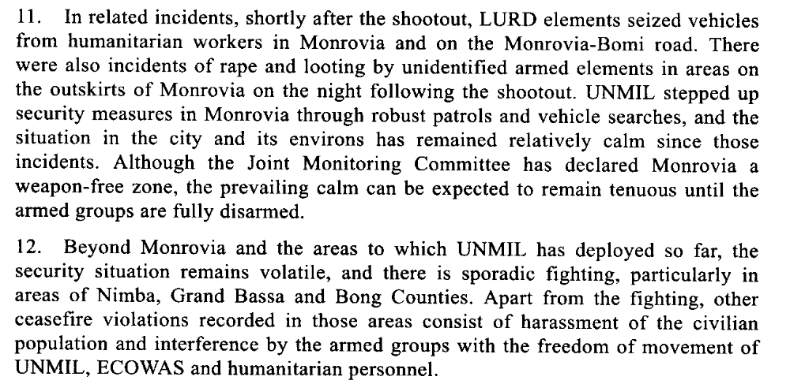
First Progress Report of of the Secretary-General on the United Nations Mission in Liberia, 15 December 2003

Assessment

Short-term compliance
No or marginal compliance (1) | X Medium low compliance (2) | Medium high compliance (3) | Full or almost full compliance (4)

Considerations underlying the assessment

The demand addressees complied in a minority of incidents covered by the demand.

Medium-term compliance

Description of the addressee(s)’ conduct

[…], there were reports of localized looting and harassment of civilians by combatants from the Movement for Democracy in Liberia (MODEL). Meanwhile, on 17 July, armed LURD combatants looted foodstuffs intended for a food distribution programme from a warehouse near Gbah, a village close to the Sierra Leonean border. There have also been reports of assaults on personnel from non-governmental organizations in the same area and of the re-establishment of some illegal checkpoints, which UNMIL troops have acted swiftly to remove. In Tapeta, Zwedru, Harper, Greenville, River Cess and Monrovia, ex-combatants have continued to extort money from the locals (...).
38. As security has improved and disarmament has progressed, more personnel from UNMIL, United Nations agencies and non-governmental organizations have been deployed to the field, resulting in improvements in the delivery of relief aid to communities that had previously been inaccessible.
Fourth progress report of the Secretary-General on the United Nations Mission in Liberia 10 September 2004, S/2004/725

5. There has been general respect for and maintenance of the ceasefire in Monrovia and other parts of the country since December 2003, although a number of minor ceasefire violations perpetrated by elements of all three armed groups have been reported outside the capital. For instance, there were incidents of sporadic shooting among Liberians United for Reconciliation and Democracy (LURD) combatants in Gbarnga and Voinjama on 11 and 16 January respectively, in Tubmanburg on 30 March and again in Gbarnga on 8, 9 and 11 April. Those incidents were reportedly related to the leadership struggle within LURD between Sekou Damate Conneh and his estranged wife, Aisha Keita Conneh. On 20 March, elements from the Movement for Democracy in Liberia (MODEL) fired into the air and looted a number of shops and houses in Buchanan during a violent confrontation between a crowd of civilians and MODEL combatants.
6. There have been some reports of harassment of civilians, including criminal activities, extortion and looting, by elements of all three armed factions. UNMIL expects that such incidents, including ceasefire violations, will decrease as the disarmament, demobilization, rehabilitation and reintegration programme progresses throughout the country.
Report of the Secretary-General pursuant to Security Council resolution 1521 (2003) regarding Liberia

During this time, over 5,000 ex-combatants were granted admission into the DDRR programme. According to one NCDDRR official, however, there is no question that many legitimate ex-combatants were left behind, many still with arms. This sentiment appears to be shared by many Liberians, and prior to the closure of disarmament, both LURD and MODEL representatives made public appeals for DD to be extended. Their concerns were reinforced late in November 2004 when reports emerged that some ex-combatants in Zwedru were erecting roadblocks and harassing UN personnel to protest the DD closure. They claimed to still have weapons and wanted to disarm p.134.
Nicolas Florquin and Eric G. Berman. 2005. “Armed and Aimless: Armed Groups, Guns, and Human Security in the ECOWAS Region. Small Arms Survey.
http://www.smallarmssurvey.org/files/sas/publications/b_series_pdf/AA/A&A-full_manuscript.pdf

Assessment

Medium-term compliance
No or marginal compliance (1) | Medium low compliance (2) | X Medium high compliance (3) | Full or almost full compliance (4)

Considerations underlying the assessment

Within the two years following the adoption of the resolution, the demand addressees complied with those aspects of the demand which were of relatively high significance to the achievement of the objectives.

Depth of demand

Assessment

Level of depth of demand
X Low depth of demand (1) | Medium depth of demand (2) | High depth of demand (3)

Considerations underlying the assessment

This demand did not put at risk the demand addresses nor did it impact on their chances to win power in the aftermath of the civil war.

Level of confidence about coding decisions

Level of confidence about coding decision
Extremely high | X High | Moderate

Comments to IPI (if any)

